String Examples:

String is Palindrome:
Reverse krne pr bhi same string bne like - ABCDCBA
Using String –
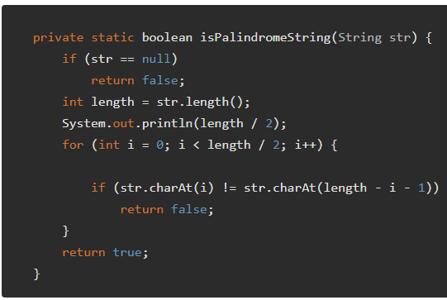
Using StringBuilder – Direct method to reverse a string:
